Problem Statement: What is the height and position of the blood splatters at the crime scene?
Hypothesis: The blood fell from a distance of 5 ft.
Independent Variable: The height of each droplet.
Dependent Variable: The size and pattern of each droplet/splatter.
Materials: Ring Stand, Simulated Blood, Pipette, Paper, PPE, Ruler.
Control: Number of drops.
Procedure: Measure the ring stand’s height and place the dropper into the clamp. Allow one drop of the blood to release onto the paper. Measure the size of each blood splatter in centimeters. Repeat steps with different ring stand heights.
Results: The table holds the data for the distance of how far the blood was dropped and the width of the blood droplet. The graph shows that as the height of the fall increased, the width of the blood droplet increased also.
Height dropped from (ft.) | Length of blood droplets (cm.)
1 | 1.5
2 | 1.5
3 | 1.8
4 | 2
5 | 2
6 | 2

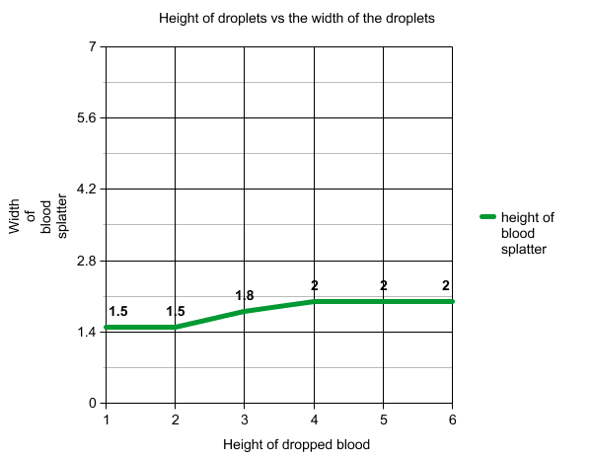
Conclusion: The hypothesis was incorrect because the droplet width of 1.8 cm in the experiment is closer to the width of the crime scene splatter.
Summary: While completing the trials, the height of the crime scene spatter was revealed by finding the different widths of each droplet from varying heights. The width of the spatter found at the scene was approximately 1.8 cm, which matches with the width of the blood dropped from a height of 3 ft. found in the lab at a 90 degree angle. The higher the drop the bigger the splatter.

