- Does your EKG change between sitting and laying down?
- Your heart beat will decrease while laying down since it is easier for the blood would pump easier. The heart does not have to use as much energy and blood is also circulated better by laying down. The way of sitting and laying down, as well as the equipment will not be changed for each person, but the way of performing the experiment will (sitting or laying down).
- Logger pro machine, an EKG machine, a computer, the logger pro software, and EKG stickers were all used in the experiment. For safety reasons, the cords on the EKG machine shouldn’t be latched onto skin. The results would be able to be compared to known normal EKG results found from other sites. The data table will be designed to hold the time intervals of all 4 EKGs. Graphs will be used to also show the EKGs.

Interval | Time (s) Lucas Sitting | Time (s) Lucas Laying Down | Time (s) Meghan Sitting | Time (s) Meghan Laying Down
P–R
QRS
Q–T
R–R

  - Data
Interval | Time (s) Lucas Sitting | Time (s) Lucas Laying Down | Time (s) Meghan Sitting | Time (s) Meghan Laying Down
P–R | .05 | .05 | .1 | .1
QRS | .1 | .1 | .1 | .1
Q–T | .3 | .4 | .2 | .4
R–R | .7 | .8 | .8 | .9

Lucas: sitting
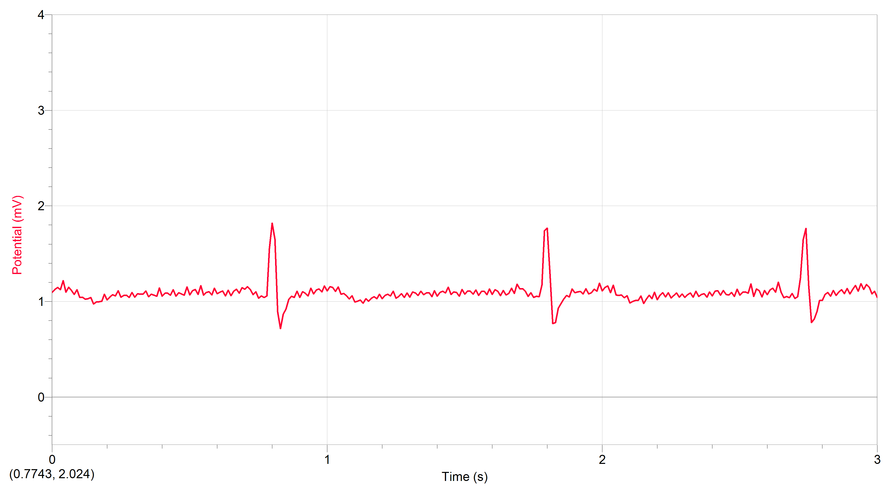
Meghan: sitting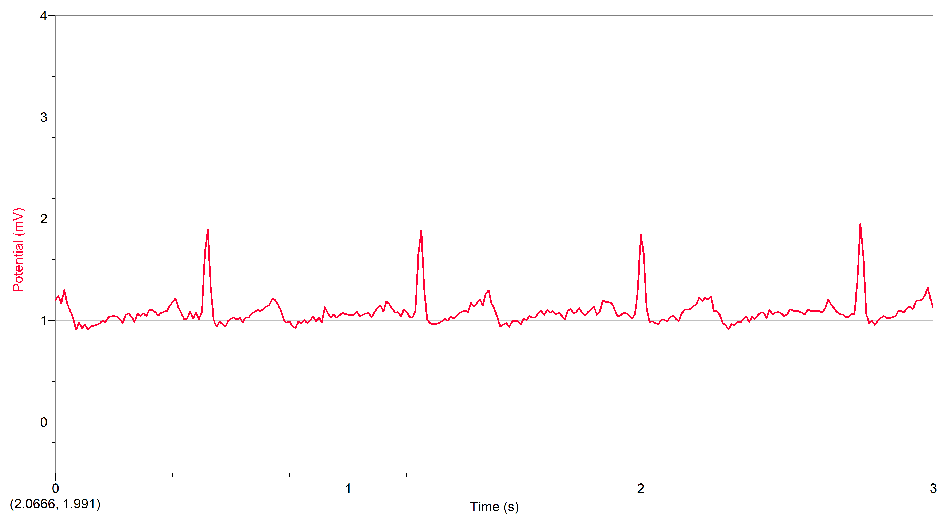

Lucas: laying down
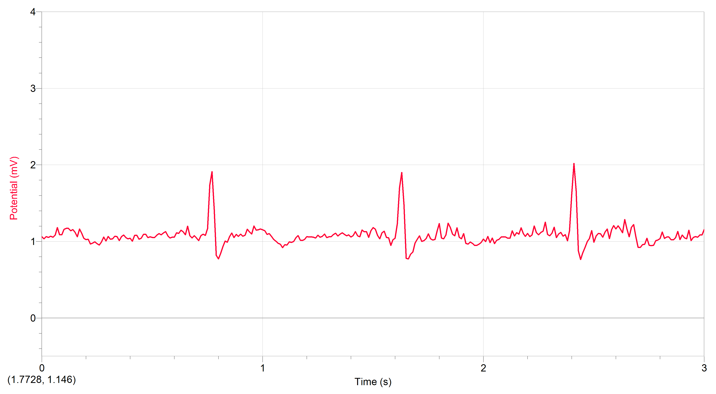

Meghan: Laying
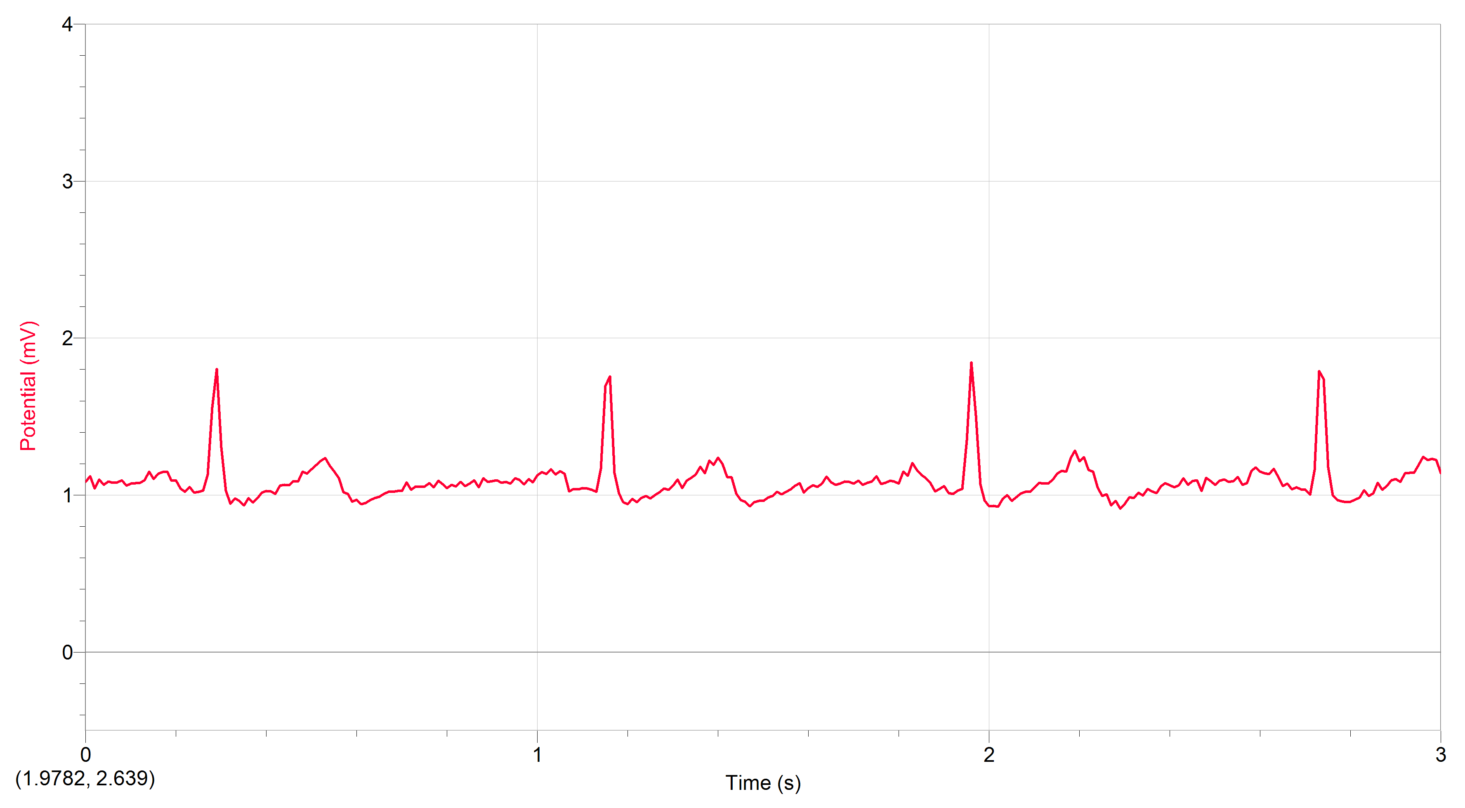
6.Our data supported the hypothesis that lying down would decrease the speed of the heart beat.
7. The EKG reads that laying down reduces the speed of your heart beating. It does so because the blood vessels in your legs help push blood upwards into your heart and your heart is also not having to pump more oxygen into cells. The EKG helped back this up by showing longer R-R ranges while laying down. Unfortunately, the results were not as accurate as most and some of the graphs did not show the second part of the heart beat.
8. An EKG after running vs sitting or laying down could also show how fast the heart would beat after running

