The Effect of Ultraviolet Rays on Yeast Growth
Meghan Mumpower and Caroline Stroud
November 10, 2014

Abstract: The purpose of the experiment is to see the difference in protection of tanning oil versus sunscreen on yeast cells. The yeast cells were exposed to UV light after having a protective layer of each substance. After this was done, the results showed that the tanning oil does not effectively protect cells, but sunscreen works well. Based on these results, it shows that people who use tanning oil are not protecting their bodies minimally.
Background: Over time, many scientists have studied the sun’s effect on us humans. As more and more information becomes known to the public, the scarier the damaging effects become. When the sun beats down on us, two types of ultraviolet radiation hit our skin, UVA rays and UVB rays both have fatal effects on humans. UVB rays are very powerful and the radiation reaches down into the dermis layer of our skin. This mainly causes severe freckling, tanning, and causes wrinkling. This type of radiation does the most damage to our cell’s DNA and even on cloudy day penetrates the atmosphere; this is why researchers tell people to wear sunscreen on an everyday basis. The other type of UV rays that damage skin is UVA rays. Although they are not nearly as powerful, these rays can penetrate farther into the skin and eventually reach the collagen. These rays tend to cause long-term damage and are a prominent cause of skin cancer; this damage is hard to detect since it often does not leave sunburn. UVA rays are the same type of rays used in tanning booths. These rays do not only cause the severe damage from tanning, but also cause cataracts.
Despite all of the proof that shows the damage the sun causes, often, people do not care that they could develop serious medical conditions as a result. A lot of teenage girls think that the only thing that is important is developing a tan. Many girls use tanning oil and a rarity is them applying sun screen. The goal of this experiment is to show these people the differences in protection of each method by exposing yeast cells to UV radiation.
Hypothesis: The SPF 50 sunscreen will protect both yeast strains more effectively than the tanning oil will when exposed to UV radiation.
Materials and Methods:
Materials: Petri dishes, yeast cells (mutant and wild strains), tin foil, pipettes, test tubes, UV light, incubator, glass beads, saran wrap, tanning oil, and SPF 50 (baby) sunscreen
Methods: Two petri dishes, one with wild type yeast and the other with mutant type yeast, is cultured to obtain the yeast. Place the yeast in to two separate test tubes and add 5nm of distilled water. Shake the test tubes to distribute the yeast throughout the water. Take 1 nm of the water and put it into the lid of one of the petri dishes. Put 5 glass beads into the petri dish and swirl the yeast around the petri dish. After the water has dried in the dish, dispose of the beads. Remove the lid and place saran wrap over the entire petri dish. Cover half of each dish with tinfoil and put under the UV light for 15 minutes. Remove from the light and tinfoil. Cover the mutant type yeast completely with tin foil, and incubate overnight. To begin the experimental work, obtain four blank petri dishes and repeat all of the above steps. However, once the saran wrap has been applied, add tanning oil to the top of two of the dishes and sunscreen to the other two dishes.
Results and Discussion: When analyzing the yeast strains, the results showed that there was a problem with the wild type yeast control; it should have grown everywhere regardless of exposure to UV light. This error was caused due to the yeast either being overexposed to the UV light or that the yeast was too close to the UV light. The mutant type yeast control had the correct results and only cells shielded by the tinfoil grew. The experimental results showed that yeast strains protected by tanning oil had more difficulty growing, but the tanning oil did not protect the mutant yeast strain what so ever. The sunscreen protected both strains of yeast well and both had lots of growth. The hypothesis was supported since the sunscreen greatly helped protect the yeast while the tanning oil did not provide adequate protection. This also shows how people that are developing a tan are only causing damage to themselves, and how using tanning oils does not reduce their risk of skin problems later in life. To expand this experiment, different types of sunscreens could be tested to see which one is the most effective in protecting people’s skin.
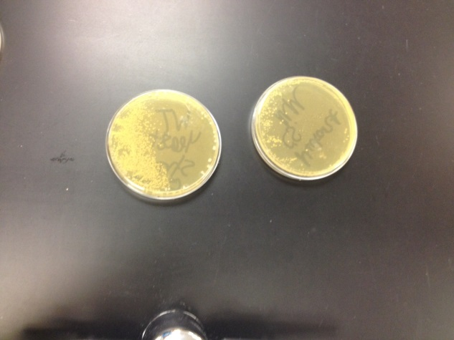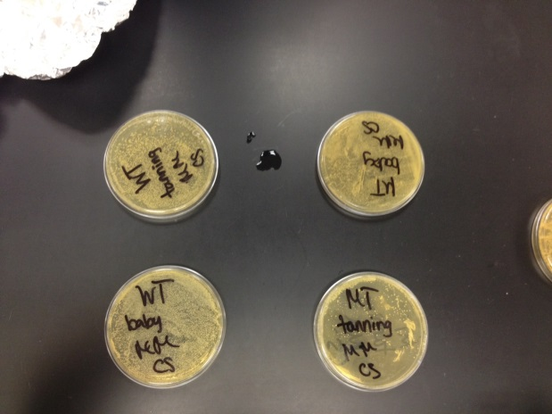
Conclusion: The yeast that was protected by sunscreen grew much better than the yeast that was protected by tanning oil.
Citations:
American Cancer Society ( February 2014). What is Ultraviolet radiation? Skin Cancer Detection and Early Prevention. http://www.cancer.org/cancer/cancercauses/sunanduvexposure/skincancerpreventionandearlydetection/skin-cancer-prevention-and-early-detection-what-is-u-v-radiation

